14 Feb. 22

SMD - Surface Mount Device

DIP - Dual in-line packages

Arduino Platform and ESP Platform

* Best board to get started with Arduino platform.
* Most used board in the family of Arduino boards.
* Based on ATmeag328P, 8-bit Microcontroller.
* Can be programmed with the Arduino IDE.
* Works of 16 MHz Clock.
* 14 digital input/output pins.
* 6 PWM outputs.
* 6 analog inputs.
* USB to serial converter.

IDE – Integrated Development Environment.

Clock signals are used to synchronize programs execution. It is used to find time required for program execution.

There are two types of sensors: Digital and Analog.

Void setup()

Will be executed only when the program begins (or reset button is pressed).

Void loop()

Will be executed repeatedly.

Control Structures (Conditional statements)

* if, if…else and switch case
* for, while and do…while
* break and continue
* Return
* go to

Functions required for LED interface set:

Pins: Analog and Digital

Pin can act as input or output pin.

Pin mode function

pinMode()

Configures the specified pin to behave either as an input or an output.

**Syntax**: pinMode(pin, mode)

Parameters:

Pin: pin number to Set for given mode

**Mode**: INPUT,OUTPUT or INPUT_PULLUP.

Whenever you want to send data, pin must be configured as output pin.

Whenever you want to read data, pin must be configured as input pin.

digitalWrite()

If the pin has configured as an OUTPUT digitalWrite a high or a LOW value to a digital pin.

If the pin is configured as an INPUT digitalWrite() will enable or disable internal pullup on the input.

digitalRead()

Reads the value from a specified digital pin, either HIGH or LOW.

**Syntax**: digitalRead(pin)

Parameters:

Pin: pin number whose value to be read

Example

byte Val = digitalRead(11)

15 Feb. 22

* Synchronous

1. Synchronous Peripheral Interface (SPI)
2. Inter Integrated Circuit Interface(I2C)

* Asynchronous

1. Serial Communication Interface(SCI)

Baud rate = No. of bits transmitted per second

Unit of Baud rate is bps(bit per second)

Serial monitor is used to display results.

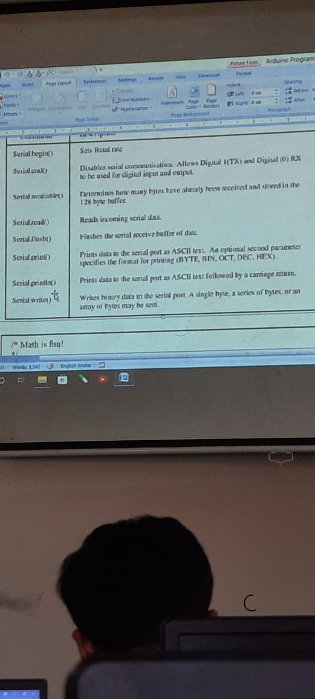

Serial Communication Program

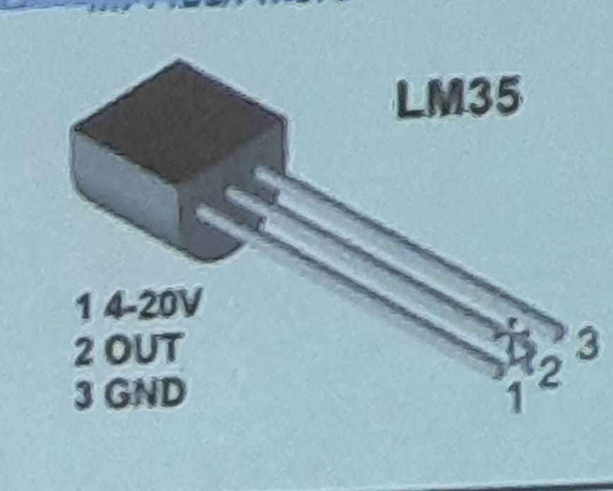

16 Feb. 22

Ultrasonic Sensor (HC-SR04)

Ultrasonic sensor has 2 parts one is called as transducer to create sound. This is called as trigger pin and indicated by T. Another part is to listen the sound or echo. This is indicated as echo pin and it is indicated as R.

Transducer sound will travel and it will identify the obstacle strikes back and is received as echo.

Formula: To measure the distance the sound has to travel 2 times back and forth

Distance = (Time*Speed of Sound)/2

Sound travels 340 m/s = 29 m/us

For cm= (us/2)/29

Pulsen is an inbuilt function pf ultrasonic sensor

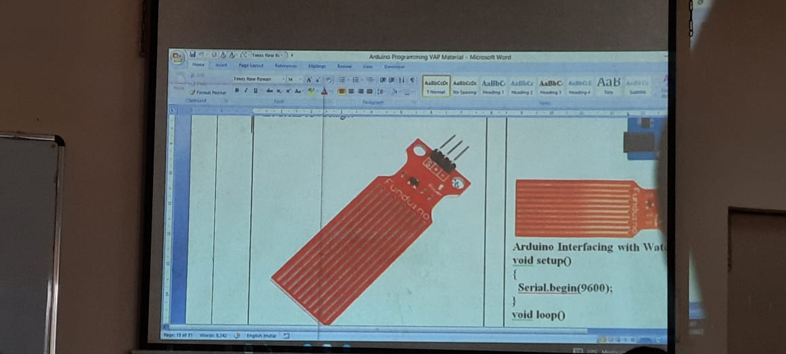

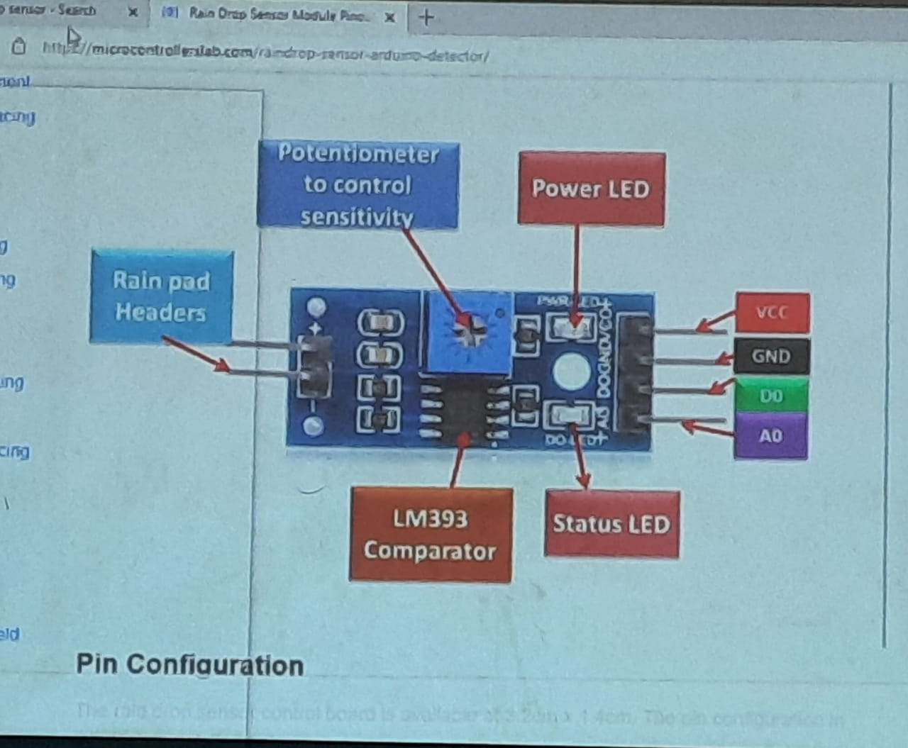

17 Feb. 22

